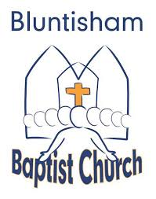

Reflective Service
18th April 2025
10.00

Declared Innocent

Welcome, Call to Worship and Introduction

Hymn: My Lord, What Love is This
https://www.youtube.com/watch?v=7Ye0sve5nmI
Reading: Matthew 27:1 - 26 – Declared innocent by Judas and Pilate’s wife - Howard

Reflective time

Hymn: You Laid Aside your Majesty
https://www.youtube.com/watch?v=KFICAbIxv_M

Reading: Luke 23:13 – 25 Sylvia and Luke 23:32-43 - David – Declared Innocent by Pilate, Herod and thief on the cross -

Reflective time

Hymn: You Chose the Cross (I’m lost in Wonder)
https://www.youtube.com/watch?v=x1AwbqZQyPU

Reading: Luke 23:44 - 56 – Declared Innocent by the Centurion – Jan Ireland

Reflective time

Easter Hallelujah https://www.youtube.com/watch?v=-j3NZEdHQaI

Hymn: Here is Bread, Here is Wine
https://www.youtube.com/watch?v=GgysV3EZKas
Communion

Closing Hymn: O Praise The Name (Anastasis https://www.youtube.com/watch?v=LqBpifDpNKc

Closing Benediction

