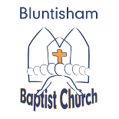
Bluntisham Baptist Church. 8th June, 2025
Pentecost Sunday – 150 Anniversary of Present Building
All Age Service

Building the Church
Welcome Paul
Call to worship Come Holy Spirit All
Songs Praise God from whom all blessings flow 890
Holy Spirit rain down 1285
Prayers of thanks and praise Paul
Story of the Present Building Helen
Songs The Rock (played live by band)
Reading 2 Chron. 6:1-3, 18-21, 7:1-3 read by all
Intercessory Prayers Izzy
Reading Acts 1:6-9, 2:1-12 read by all
Song All I have and all I am is yours (Build this house)1697
Building the Best Church Ever. activity Paul
Song Lord for the years 892
Final Prayer Paul

