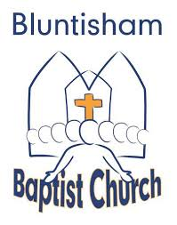

Bluntisham Baptist Church
7th September 2025

Welcome and introduction

Call to Worship Wayne

Hymns/songs of worship: 2407 Let Our Praise Be Your Welcome
1158 All My Days
All Age Lucy
(Presentation of Bibles)
All Age Song: 880 Let Everything That Has Breath

Youth and children leave

Prayers Simon

Scripture Reading Glenna

Sermon – The Way Simon

Hymn/Song: 1117 Who Is There Like You?

Welcome Jamie and Becca into the Fellowship Simon

Communion Wayne

Closing Hymn 523 Thank You, Jesus, Thank You Jesus

Benediction Wayne

