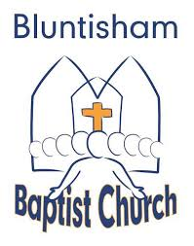

Bluntisham Baptist Church, 6th July 2025, 10.30am

Why should we pray?

Welcome Simon

Call to Worship Simon

Song: Come People of the Risen King 2249 in C
Song: How Lovely is Your Dwelling Place 781 in E

All Age – Keep On Praying Simon

Song: Nothing’s Too Big, Big, Big – audio track

Sunday School and Youth leave for their groups.

Song: Still You Speak 2531 in E

Scripture Reading – Philippians 4:4-7 Chris

Sermon – Why should we pray? Simon

Song: Jesus Christ (Once Again) 865 in Eb

Communion Simon

Prayers of Intercession Aggie
Closing Song: We Have a Strong and Certain Hope 2612 in E.
Blessing Simon

