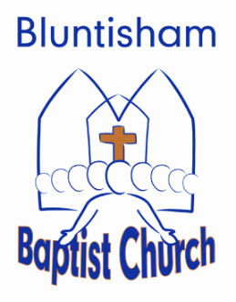

Order of Service 3rd August 2025
All-age Service – Whole Church Worship

Welcome and notices: Peter

Introduction to series: Peter

Video: Peter

Song: Your Love is Amazing (1676)

Activity: Would you rather? Peter

Song: The Splendour of the King (How Great is Our God) (2065)

Reading: 1 Corinthians 12: 12-20 Elizabeth

Talk: Peter

Prayer: Peter

Song: Blessed Be Your Name (1193)

Communion: Peter

Song: Let Everything That Has Breath (880)

Close and blessing: Peter

