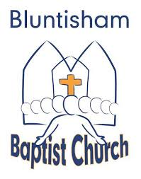

Bluntisham Baptist Church, 26th October 2025, 10.30am

Welcome/Notices Simon

Call to Worship Simon

Song: King of King Majesty – Worship Lyric Video

Prayer of Thanks Simon

Song: This is amazing Grace – Worship Lyric Video

Quiz Anna

Song: Oceans -where feet may fall – Worship Lyric Video

Talk: Mission Direct Trip Anna

Wonderful World Psalm Reading Anna

Song: Wonderful, Wonderful World (Video)

Interview with Anna Simon/Anna

Prayers with Sweets Anna

Song: City on a Hill (C) Simon/Matt

Response to Mission Month Simon

Closing Song: Show your Power (E) Simon/Matt

Blessing: Simon

