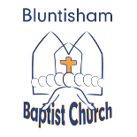
Bluntisham Baptist Church
18th May 2025
Fruit of the Spirit – Self Control

Welcome and Call to worship Katy
Songs: Strength Will Rise 2034
Open the Eyes of my Heart Lord 1490
All-age Talk ppt slide Katy
Song: Love the Lord Your God with all your heart - video https://www.youtube.com/watch?v=HoJ2SjQtPPY

Children and young people leave after prayer

Song: Be Still 40
Time of quiet prayer ppt slide
Reading Psalm 51:1-12 ppt slide Brian
Sermon ppt slides Jonathan
Song: Mighty to Save 1757
Final Blessing Katy

