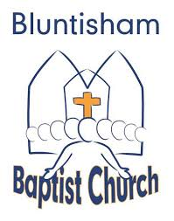

Bluntisham Baptist Church, 17th August 2025, 10.30am
Theme: Upside Down Worship

Welcome/Notices Simon

Gathering Prayer Simon

Song: Come People of the Risen King (C) CCLI 5232617
Song: The Body Song (video)

Teaching: A Strange Kind of King Simon

Song: The Splendour of the King (How Great is our God) (A) CCLI 4348399

Bible Reading: Mark 10:32-45 Simon

Song: King of Love and Grace (Guardian) (C) CCLI 6273778

Teaching: The Servant King Simon

Discussion: Simon

Song: From Heaven you came (Servant King) (Eb) CCLI 78897

Response: Paper Crowns Simon

Closing Song: Build your Kingdom (Come set your rule) (C) CCLI 6186078

Sending Prayer Simon

