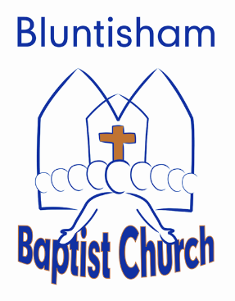
Order of Service 16 November 2025
Jesus Heals

Welcome: Graham C

Songs x2 : 1) 1819 Hear The Call Of The Kingdom 4930752 2) (Sheet) Christ Was Raised 7073062
Church Family News: Graham C

Song: 2612 We Have A Strong And Certain Hope 5463125

Street Pastors Commissioning: Simon

Prayers for children & young Simon
People:

Children and Young people exit.
***********************

Prayers of intercession: Allan Moore

Song: 757 Everyone Needs Compassion 4591782
Reading: Anita Catterick- Luke 5 vs 12-26

Sermon: Simon

Song: 1775 From The Highest Of Heights 4403076

Close and blessing: Graham C

Reading: Anita Catterick- anitacattshome@gmail.com
Song chooser: Ben Stephens – bencarlestephen@gmail.com
Powerpoint: Matt – matthew_spendiff@hotmail.com
Prayers: Allan Moore - allanmoore0802@gmail.com

