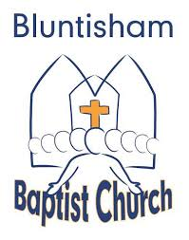

Bluntisham Baptist Church, 14th September 2025, 10.30am

Welcome/Notices Simon

Call to Worship Simon

Song: Forever (Chris Tomlin) CCLI 3148428
Song: Jesus is the Name we honour SoF 870 CCLI 871991

All-age Talk: Simon

Song: Nothings too big big big (on video)

Sunday School and Youth leave Simon

Song: To Be in Your Presence SoF 1067 CCLI 918122

Prayer of Intercession Simon
& Song: Be Still and Know SoF 41 CCLI 583265

Song: King of Love and Grace (Guardian) SoF 2939 CCLI 6273778

Reading: Luke 3:21-38 Brian

Sermon: Peter

Closing Song: He is the Lord and he reigns on high (SoF 755) CCLI 861891

Blessing Simon

