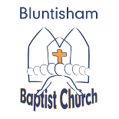
Bluntisham Baptist Church.
13th April 2025. Palm Sunday

Welcome Paul
Call to worship Zechariah 9:9 Paul
Songs 1205 Come now is the time to worship
2359 In all I do
Prayers of thanks and praise Paul
Reading Luke 19:28-44 Jim
Sermon
Prayers Aggie
Song 483 “Restore, O Lord, the honour of your name”
880 Let everything that has breath
Children enter Anna and the young people
Palm Crosses
Song 189 “Hosanna, hosanna in the highest”
Final Prayer

