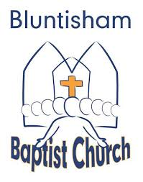

Bluntisham Baptist Church, 12th October 2025, 10.30am

Welcome/Notices Simon

Call to Worship Simon

Song: Be thou my vision - SF 42 - CCLI 30639 - in D

Song: I will offer up my life - SF 851 - CCLI 1083764 - in D

All-age Talk Ully

Song: Everyone needs compassion - SF 1757 - CCLI 4591782 - in F

Children and Young People go out to groups Simon

Song: Oh to see the dawn (the power of the cross) - SF 1988- CCLI 4490766-in C

Reading:: Louise

Sermon: Ully

Song: Soften my heart - SF 505 - in D

Prayers of Intercession: Ian

Closing Song: We must go / god of justice - SF 1794 - CCLI 4447128 - in E

Blessing: Simon

