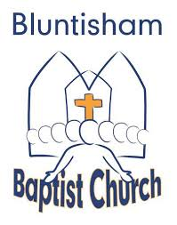

Bluntisham Baptist Church, 10th August 2025, 10.30am
Theme: Love on another

Welcome/Notices Simon

Gathering Prayer Simon

Song: Let Our Praise Be Your Welcome 2407 in A (‘Here for You’ octave +1 in Song Select)
Song: In All I Do 2359 in G (‘This My Worship’ in Song Select)

Interview Simon

Song: The Body Song (Video)

Bible Reading with Actions Simon

Song: Let There Be Love Shared Among Us 329 in F

Talk: Acting in Love Simon

Activity – Clothed with Christ Simon

Song: The Golden Rule (Video)

Response Simon

Closing Song: Love Divine 377 in G

Sending Prayer Simon

